**DAILY ONLINE ACTIVITIES SUMMARY**

|  |  |  |  |  |  |  |  |  |
| --- | --- | --- | --- | --- | --- | --- | --- | --- |
| **Date:** | **01/06/2020** | | | | | **Name:** | **Arun K** | |
| **Sem & Sec** | **VI ‘A’** | | | | | **USN:** | **4AL17CS013** | |
| **Online Test Summary** | | | | | | | | |
| **Subject** | | **CNSC** | | | | | | |
| **Max. Marks** | | **60** | | **Score** | | | **52** | |
| **Certification Course Summary** | | | | | | | | |
| **Course** | **Python and Ethical hacking** | | | | | | | |
| **Certificate Provider** | | | **UDEMY** | | **Duration** | | | **1 month** |
| **Coding Challenges** | | | | | | | | |
| **Problem Statement:**  <https://github.com/ArunKumar9538/Alvas_onlione_coading/blob/master/README.md> | | | | | | | | |
| **Status: solved problems are : 3** | | | | | | | | |
| **Uploaded the report in Github** | | | | | **yes** | | | |
| **If yes Repository name** | | | | | https://github.com/ArunKumar9538/Alvas_onlione_coading.git | | | |
| **Uploaded the report in slack** | | | | | **No** | | | |

Online Test Details: (Attach the snapshot and briefly write the report for the same)

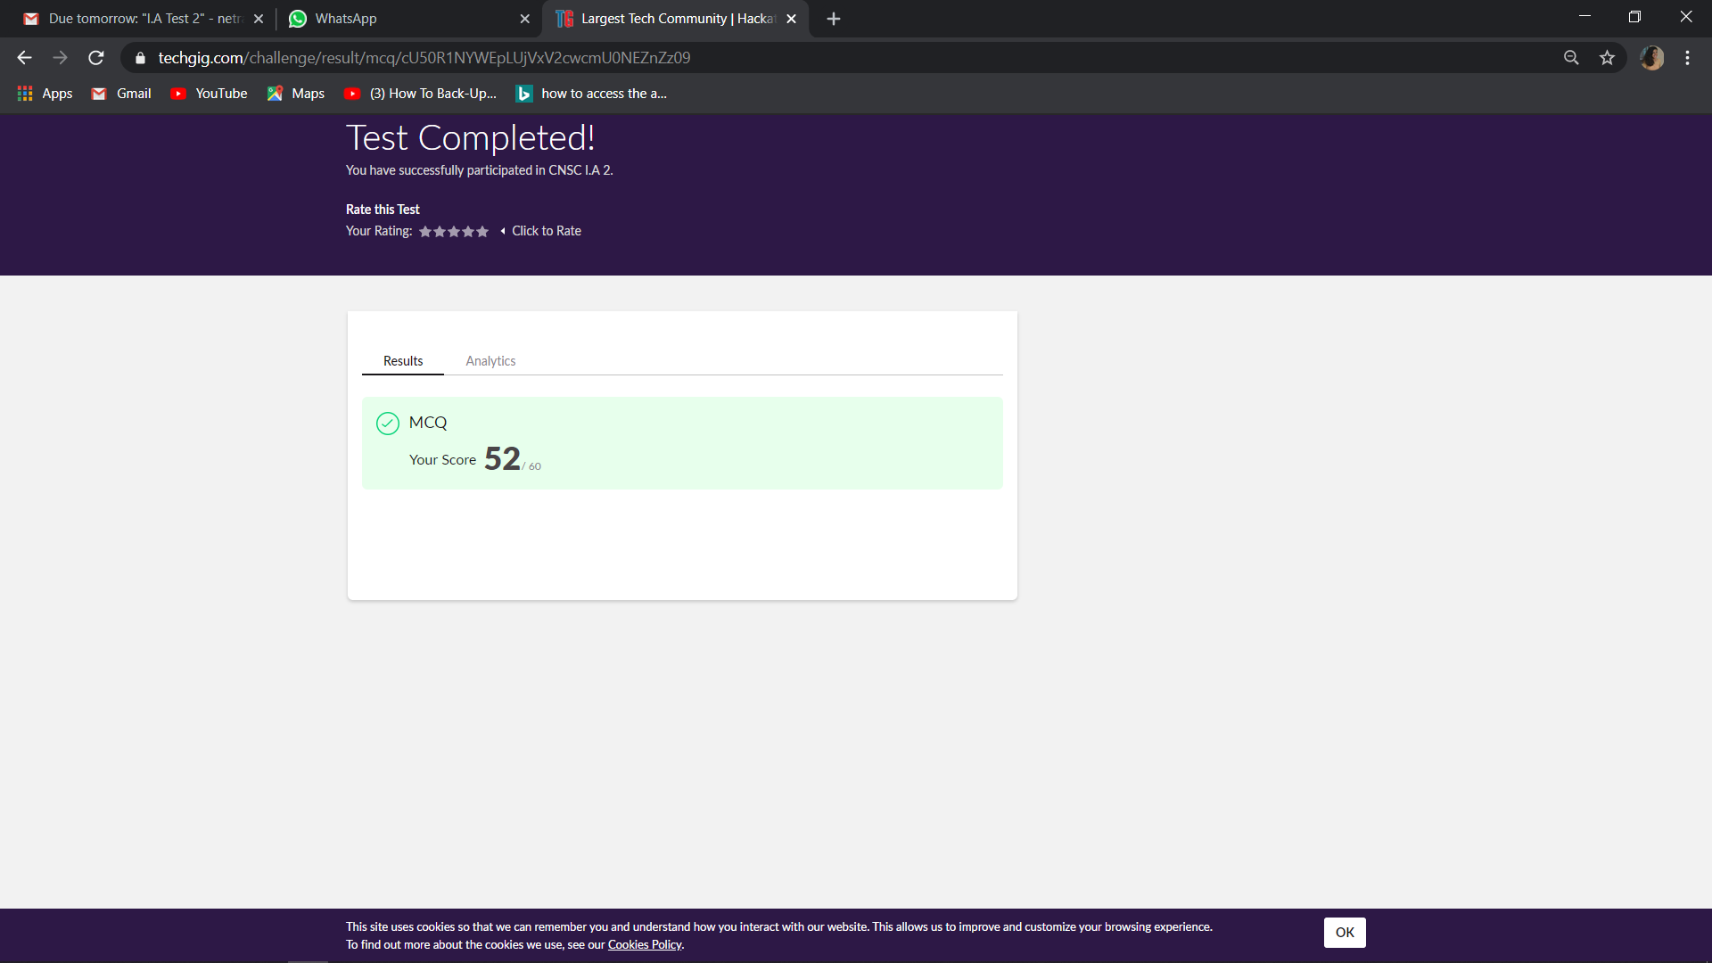

Certification Course Details: (Attach the snapshot and briefly write the report for the same)

Intercepting a packets and creating a proxy and converting packets into scapy packets. Learning about http and https and converting packets into scapy packets